Cation disorder limited IGZO mobility calculation based on Density Functional Theory

Seung Hyo Han, Deokhwa Seo and Mincheol Shin*
School of Electrical Engineering, Korea Advanced Institute of Science and Technology,
Rep. of Korea
*E-mail: mshin@kaist.ac.kr

Indium gallium zinc oxide (IGZO) is a promising candidate for future semiconductor devices due to their high mobility, low off-state current and suitability for 3D stackable DRAM configurations [1]. IGZO is also known to exhibit increasing mobility with increasing carrier density, and there have been many studies to model this unusual electrical characteristic. However, previous studies were only limited to the In:Ga:Zn=1:1:1 structure [2], or showed a difference of an order of magnitude in mobility with experimental results [3]. In this work, we calculate the cation disorder limited mobility of crystalline IGZO using density functional theory (DFT) and a model Hamiltonian. The DFT tool, SIESTA is used to obtain the atomic structures of crystalline IGZO and extract the DFT Hamiltonians. The model Hamiltonian and cation disorder potential are modeled to reproduce the transmission calculations using the DFT Hamiltonian directly. The non-equilibrium Green’s function and Poisson equation are employed in our in-house tool to calculate the conductance and transmission properties. The model calculations are in well agreement with experimental data [4] as shown in Figs. 1 and 2. Using a similar approach, IGZO structures consisting of different In:Ga:Zn ratios are further investigated.
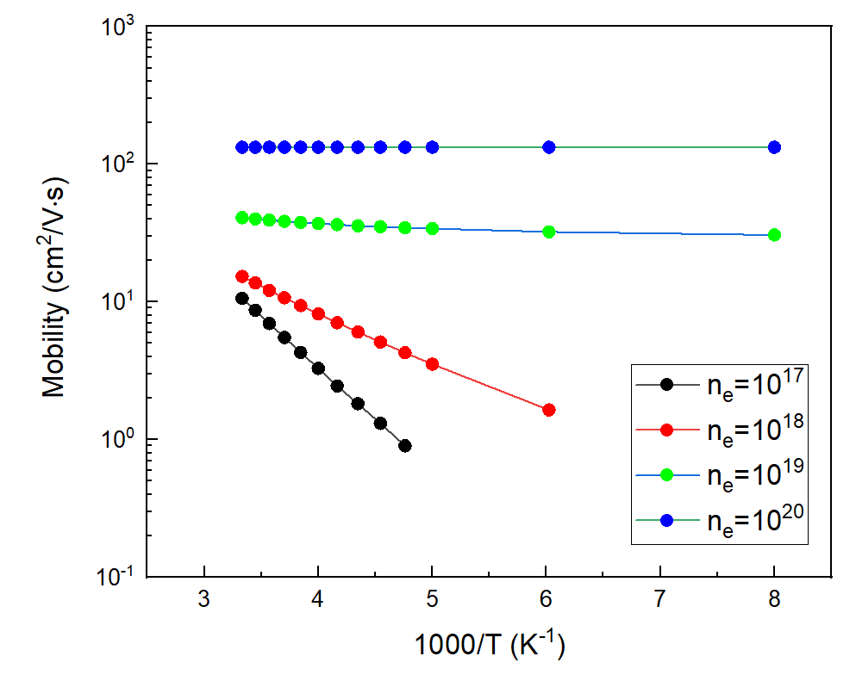 | 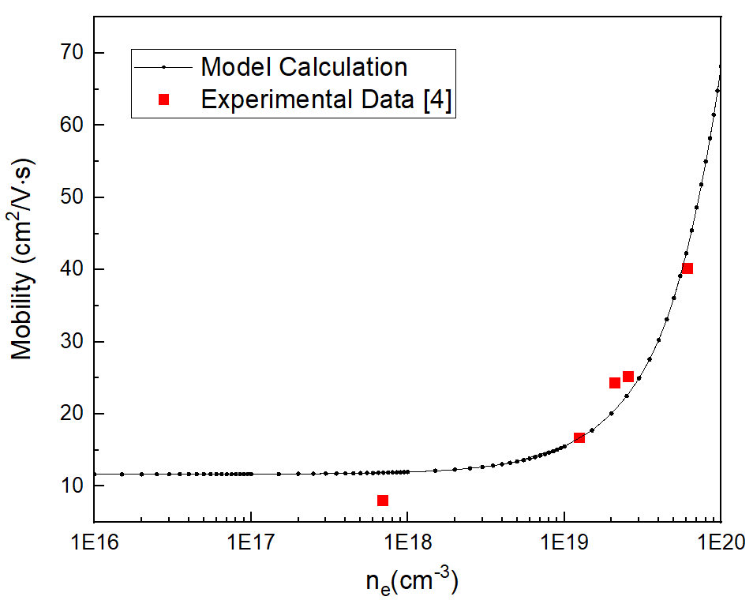
Fig 1. Calculated mobility at different temperatures | Fig 2. Calculated mobility at different carrier densities
Acknowledgments This work was a result of the research project supported by SK Hynix Inc.
References [1] Wendong Lu, et al., International Electron Devices Meeting (2022 IEDM) [2] Yoon Jegal, et al., IEEE Electron Devices Letters, Vol. 41, NO. 6, June 2020 [3] Youngho Kang, et al., Appl. Phys. Lett. 102, 152104 (2013) [4] Naoki Kase, et al., CrystEngComm, 2022, 24, 4481

